Quarterly Statistical Release
June 2015, N° 61

This release and other statistical
releases are available on efama’s
website (www.efama.org)

Trends in the European Investment Fund Industry

in the First Quarter of 2015

This report introduces a new category classification which classifies investment funds according to the regulatory definition of UCITS and AIFs

This report was prepared by Bernard Delbecque and Jonathan Healy

EFAMA
The European Fund and Asset Management Association

Rue Montoyer 47 - B-1000 BRUXELLES - Tel. 32-2-513.39.69 Fax: 32-2-513.26.43 - e-mail: info@efama.org

UCITS versus AIFs

Economic versus legal definitions

Until now, UCITS were defined in EFAMA’s statistics in the sense of being publicly offered, open-ended funds investing in transferrable securities and money market instruments. We used this approach in order to analyze the trends in comparable investment funds in terms of investment strategy and investor protection. With the introduction of the Alternative Investment Managers Directive (AIFMD) and its EU passport, which allows the marketing of an alternative investment fund to professional investors throughout the EU on the basis of a single “home state” approval, EU fund managers are no longer confined to UCITS for pan-European distribution. Hence, they will be able to unlock the European market through the use of the EU-wide marketing passport.

This important change in EU legislation for investment funds, coupled with the opportunity for the AIFMD to become a brand in the alternative investment market similar to the global brand Europe has created with UCITS, led EFAMA to make a distinction between investment funds based on the specific regulatory requirements of the AIFMD and UCITS directive. The new classification of EFAMA took effect from and including Q4 2014.

The table below shows the effect this has had upon the EFAMA statistics.

Trends in the UCITS Market

Net Sales by Investment Type

Net sales of UCITS surged in the first quarter of 2015 as the ECB launched its quantitative easing programme to combat deflation in the euro area. UCITS posted net inflows of EUR 285 billion during the quarter, up from EUR 49 billion in the fourth quarter.

Long-term UCITS attracted net inflows of EUR 240 billion, up from EUR 53 billion. Equity funds registered a turnaround in fund flows to post net inflows of EUR 39 billion, compared to net outflows of EUR 5 billion in the fourth quarter. Demand for bond funds increased to EUR 77 billion from EUR 20 billion in the previous quarter. Multi-asset funds also registered strong net inflows of EUR 101 billion, up from EUR 19 billion in the fourth quarter. Money market funds posted net inflows of EUR 45 billion, against net outflows of EUR 4 billion in the fourth quarter.

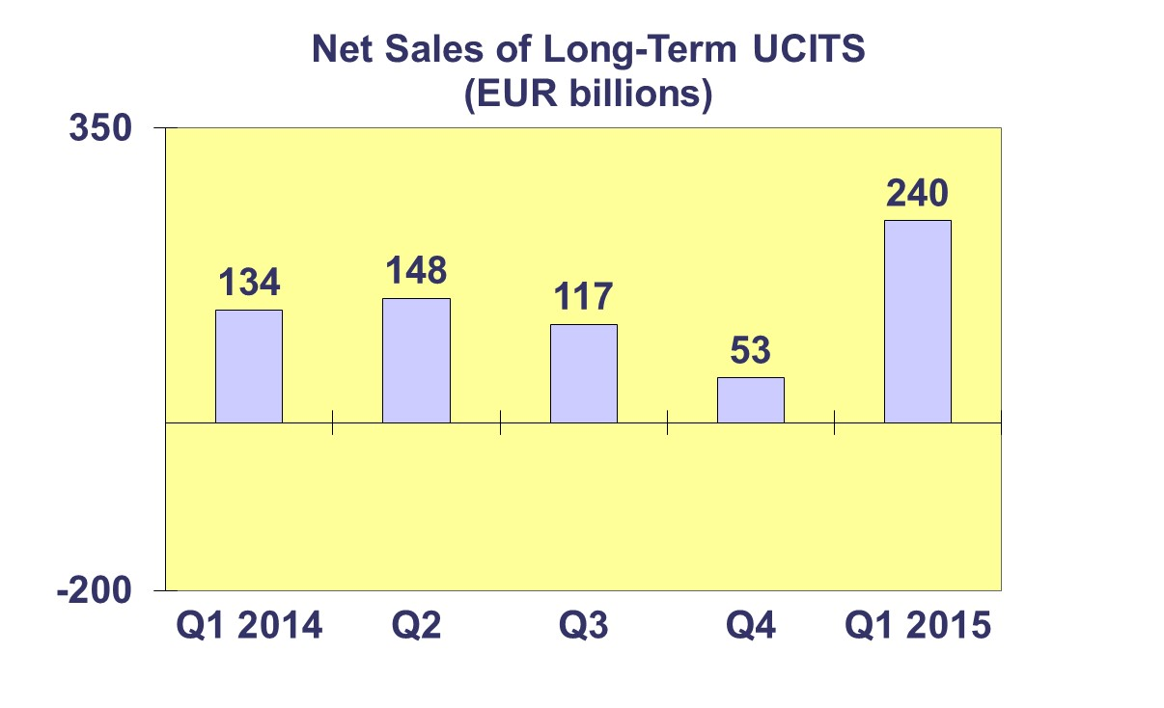
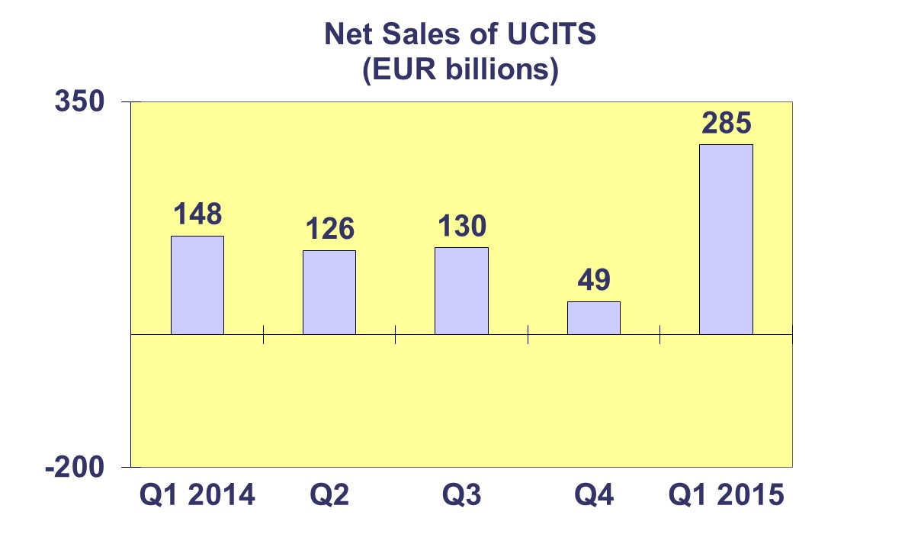

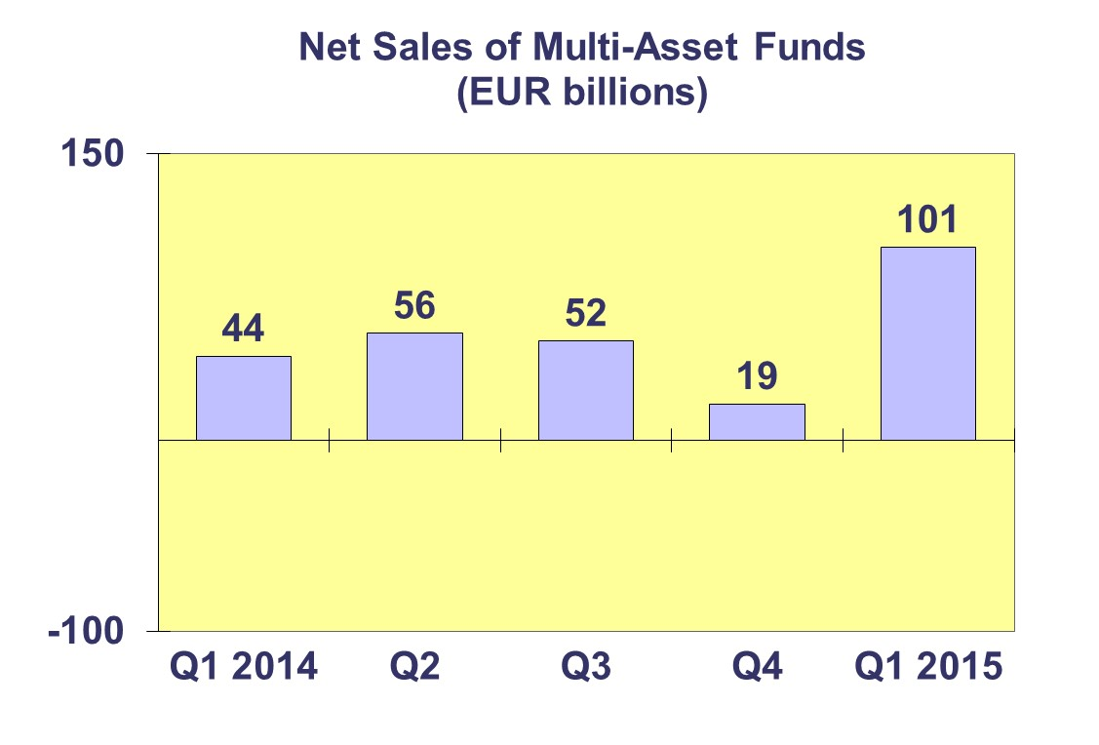
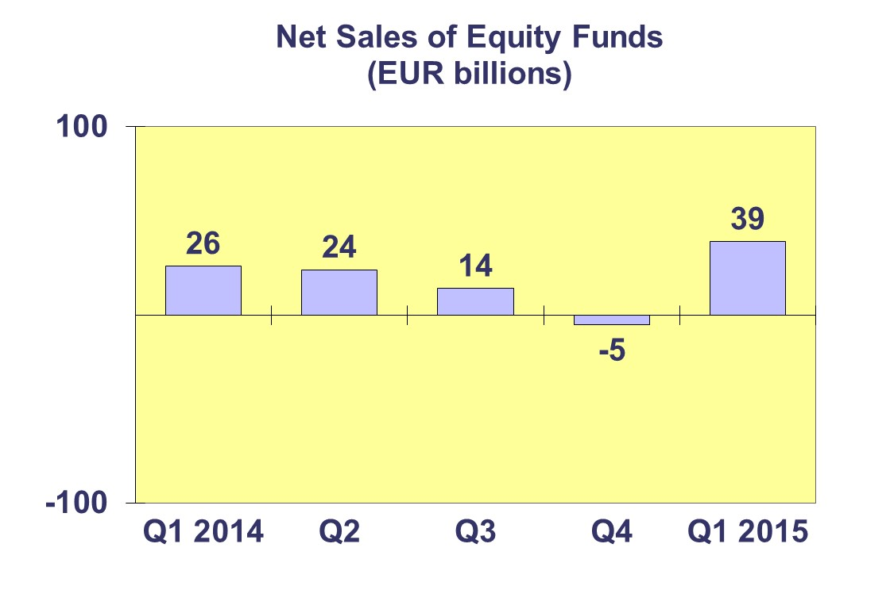
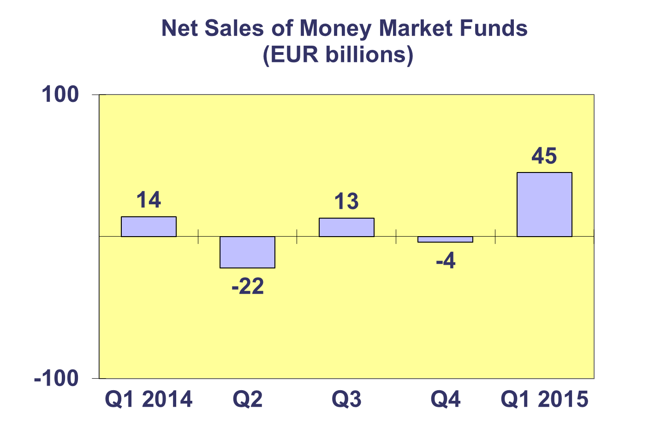
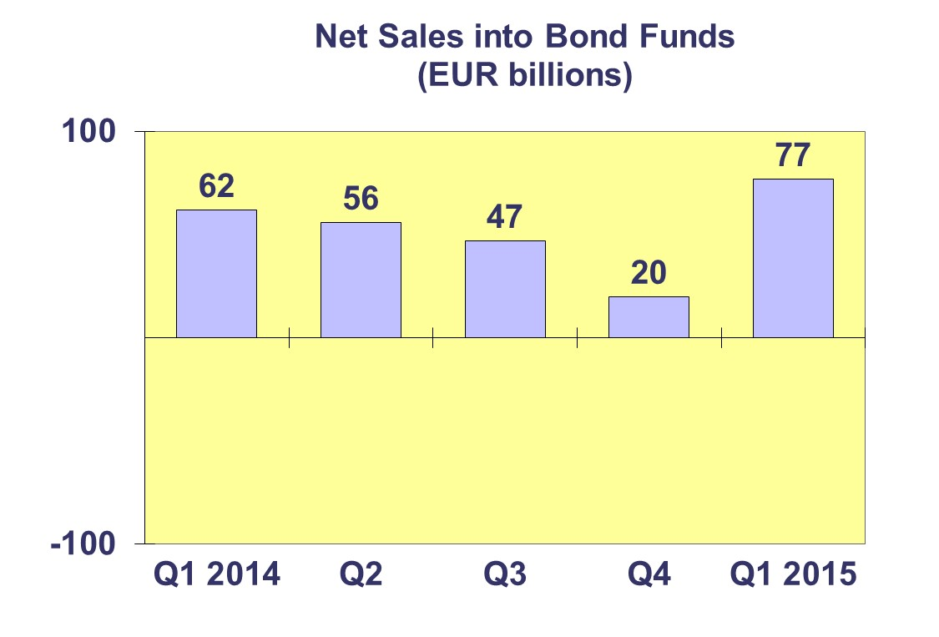

Trends in the UCITS Market
Net Sales by Country of Domiciliation

Twenty-two countries registered net inflows in the first quarter of 2015, with six countries recording net inflows greater than EUR 10 billion.

Luxembourg attracted net sales of EUR 117 billion during the quarter, registering large net inflows across fund categories. France followed with net sales of EUR 66 billion and Ireland posted net inflows of EUR 49 billion. Elsewhere, large inflows were posted during the quarter in Spain (EUR 16 billion), Switzerland (EUR 12 billion) and Italy (EUR 11 billion). Of the other large domiciles, the United Kingdom registered net outflows of EUR 9 billion during the quarter, primarily on account of large net outflows from equity funds (EUR 8 billion). Germany registered net inflows of EUR 8 billion during the quarter.

Trends in the UCITS Market

Net Assets by Investment Type

UCITS net assets rose 15.4 percent during the first quarter to EUR 8,277 billion at end March 2015.

Net assets of equity funds increased 16.2 percent during the quarter to EUR 3,144 billion. Multi-asset funds enjoyed net asset growth of 19.0 percent during the quarter to stand at EUR 1,355 billion. Bond fund net assets rose 10.1 percent to EUR 2,304 billion. Money market funds also registered increased net assets rising 10.2 percent to EUR 970 billion at quarter end. Net assets of funds of funds rose 17.6 percent during the quarter to EUR 271 billion.

The number of UCITS at end March 2015 stood at 29,311 compared to 28,792 at end December 2014.

Trends in the UCITS Market
Net Assets by Country of Domiciliation

Twenty-five countries recorded growth during the quarter as net assets of UCITS reached EUR 8,277 billion at end March 2015.

Of the largest domiciles, both Luxembourg and Ireland posted net asset growth of 14.6 percent during the quarter. The United Kingdom posted growth of 22.4% during the quarter. The appreciation of the pound sterling during the quarter vis-à-vis the euro of 6.6 percent played a role in the large growth of assets in the United Kingdom. France registered net asset growth of 16.8%, followed by Germany (12.3%). Elsewhere, large net asset growth of 17.7 percent was recorded in Switzerland and Spain during the quarter. Belgium also registered strong net asset growth of 17.5 percent. In Southern Europe, Italy posted net asset growth of 10.5 percent, followed by Portugal (9.3%). Greece registered a decrease in net assets of 4.9 percent during the quarter. Net assets of UCITS in Malta posted a decrease of 8.2 percent due to large net outflows from a fund during the quarter. In the Nordic region, net assets in Norway rose 13.4 percent, followed by Finland (12.6%) and Denmark (9.0%).

Trends in the AIF Market
Net Sales by Country of Domiciliation and Investment Type

Net sales of AIFs totaled EUR 17 billion in the first quarter of 2015, down from EUR 62 billion registered in Q4 2014.

Twelve countries registered net inflows into AIFs in the first quarter of 2015, with six countries recording net inflows greater than EUR 1 billion. Germany posted net sales of EUR 44 billion during the quarter, registering net inflows across all fund categories during the quarter. Luxembourg followed with net sales of EUR 15 billion. Of the other large domiciles, The UK posted net sales of EUR 3 billion. On the other hand, France registered net outflows of EUR 40 billion during the quarter, due to large net outflows from equity funds (EUR 20 billion) and multi-asset funds (EUR 14 billion). Ireland also recorded net outflows during the quarter (EUR 2 billion). Elsewhere, net inflows in excess of EUR 1 billion were posted in Switzerland (EUR 2 billion), Austria (EUR 1 billion) and Sweden (EUR 1 billion). Spain registered net outflows during the quarter of EUR 2 billion, as did Denmark (EUR 2 billion).

Trends in the AIF Market
Net Assets by Investment Type

Net assets of AIFs increased 7.8 percent during the first quarter to stand at EUR 4,387 billion at end March 2015.

Net assets of multi-asset funds, which account for 28 percent of all AIFs, increased 11.4 percent during the quarter to EUR 1,216 billion. Equity fund net assets increased 10.8 percent to EUR 432 billion. Net assets of bond funds rose 5.2 percent during the first quarter to EUR 774 billion, while money market funds posted a reduction in net assets of 9.0 percent to stand at EUR 86 billion. Real estate funds registered growth of 0.9 percent to stand at EUR 399 billion. Other AIFs, which include AIF funds, for which no breakdown according to the underlying fund categories is available, posted growth of 9.1 percent to stand at EUR 1,409 billion at end March 2015.

The total number of AIF funds stood at 26,271 at end March 2015, compared to 26,457 at end December 2014.

Trends in the AIF Market
Net Sales and Assets of Institutional AIFs

Institutional AIFs, which are funds reserved to institutional investors and form part of the AIF Market, increased 13.3 percent during the first quarter to stand at EUR 2,008 billion at end March 2015.

Net assets of equity funds increased 13.7 percent to EUR 215 billion. Multi-asset fund net assets increased 11.1 percent to EUR 843 billion during the first quarter. Bond funds enjoyed strong growth of 21.8 percent during the quarter to EUR 545 billion. Money market funds increased 5.1 percent to EUR 10 billion. Real estate funds increased 9.4 percent to EUR 130 billion. Other institutional assets posted growth of 6.8 percent to stand at EUR 266 billion at end March 2015.

Institutional AIF net sales strengthened to EUR 54 billion during the first quarter, after posting net inflows of EUR 44 billion in the fourth quarter of 2014.

Trends in the AIF Market
Net Assets by Country of Domiciliation

AIF net assets increased 7.8 percent during the first quarter to EUR 4,387 billion at end March 2015.

Of the largest domiciles, Germany which represents 31.7 percent of all AIF assets, posted net asset growth of 8.4 percent during the quarter. France registered a slight increase in net assets of 0.5 percent. Luxembourg AIF net assets increased 10.1 percent, whilst in Ireland net assets of AIFs increased 12.4 percent. The United Kingdom posted net asset growth of 15.9 percent, whilst Liechtenstein registered strong growth in net assets of 25.1 percent and Switzerland recorded above average net asset growth of 13.8 percent. The appreciation of the Swiss franc and pound sterling vis-à-vis the euro during the quarter supported the large growth recorded in these countries. Elsewhere, Denmark posted net asset growth of 8.6 percent, whilst Austria registered growth of 6.0 percent. In Southern Europe, growth was registered in Italy (9.4%) and Greece (2.3%), whereas Spain and Portugal recorded decreases in net assets of 2.9 percent and 2.3 percent respectively.

Trends in the European Investment Fund Industry
Net Assets by Country of Domiciliation

The combined assets of the investment fund market in Europe, i.e. the market for UCITS and AIFs increased 12.6 percent during the first quarter to stand at EUR 12,664 billion at end March 2015.

With EUR 8,277 billion invested in UCITS, this segment of the business accounted for 65 percent of the European investment fund market, with the remaining 35 percent (EUR 4,387 billion) composed of AIFs.

